Data Visualization Project  
Proposal Sketch

(Robert Delgado) (October 3, 2017)

# Data

I propose to visualize annual greenhouse gas emissions by country using historical data from the CAIT (Climate Analysis Indicators Tool). This data can be found at the following site: <http://www.wri.org/resources/data-sets/cait-historical-emissions-data-countries-us-states-unfccc>

Link to summary: <https://bl.ocks.org/RobertDelgado/3e056141ddb506059350ea9948b3af4b>

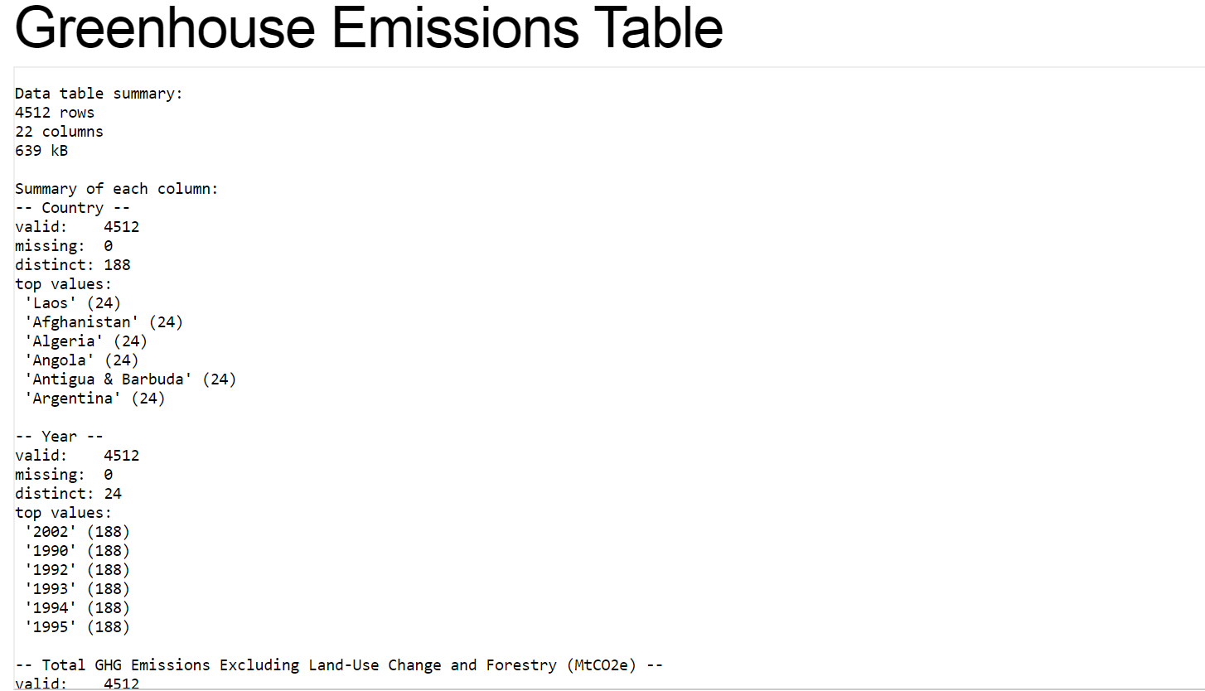

# Prototype

I’ve created a couple of proofs of concept for this visualization.

* The first proof of concept is a bar graph that shows the countries that emitted the most greenhouse gasses in 2013. (P.S. the annual greenhouse gas emission units happen to be metric tons).

<https://bl.ocks.org/RobertDelgado/327f1a936510514071c864b418b1d28e/a73885c93c13af420f2251beebb01814315629b7>

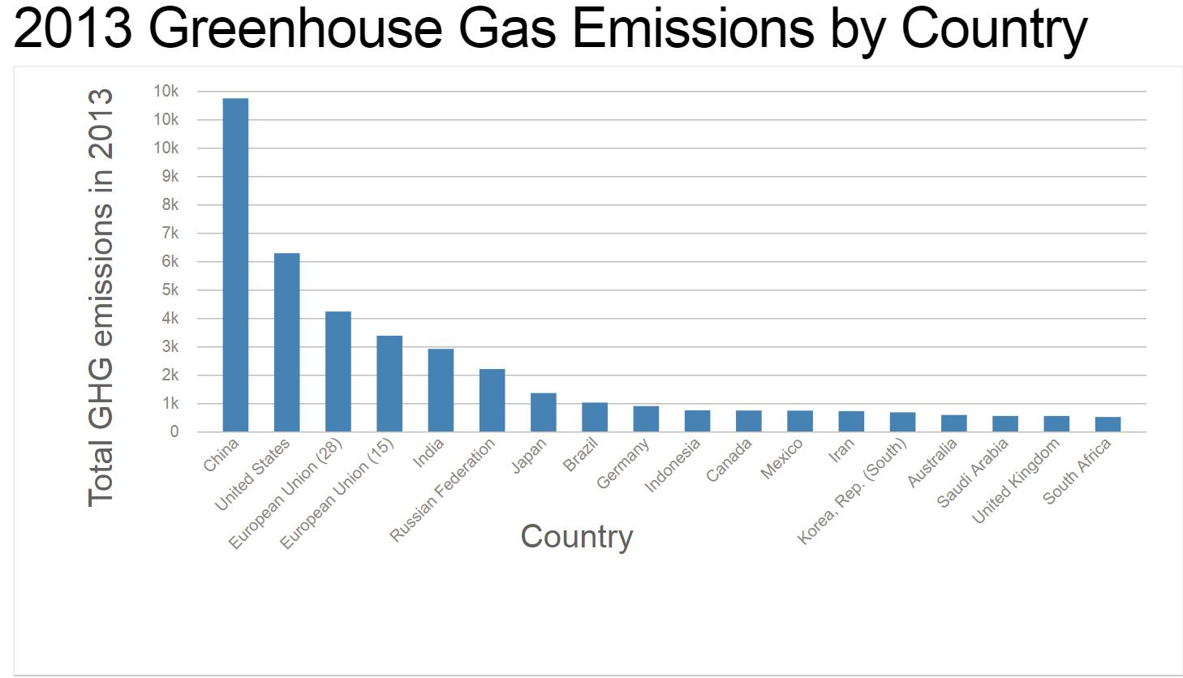

Here is a screenshot of the readme file accompanying the bar graph:

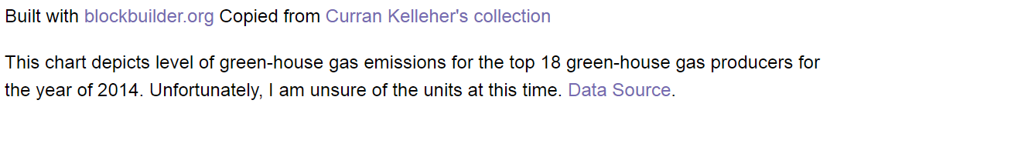

Here is a link to the bar-graph:

Link: <https://bl.ocks.org/RobertDelgado/327f1a936510514071c864b418b1d28e>

* The second proof of concept is a line graph (powered by ggplot2) that depicts the countries that emitted the most green-house gasses from 1990 to 2013.

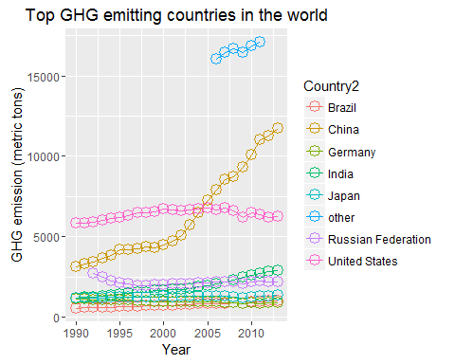

# Questions & Tasks

The following tasks and questions will drive the visualization and interaction decisions for this project:

* How do the annual GHG emissions vary over time by country?
* Who have historically been the biggest GHG emitters? Are they still the biggest GHG emitters?
* Have GHG emissions for a given country decreased over time, increased?
* Show a ranking of countries by way of annual GHG emissions?
* How does a country’s GHG emission level compare to its population?

# Sketch:

I have decided to produce my favorite sketch (from the previous proposal):

The vertical axis consists of stacked scatter plots showing the difference between GHG emissions for year i-1 and year i (for 1990 < i <= 2015). Year i, GHG emission marks will project to the vertical axis to the right of the scatter plots where a horizontal lollipop chart will show the cumulative GHG emissions for that country.

Below (on a fixed pane), will be a map with countries colored according to population (or GDP).

The user will be able to zoom in and out by time or spatially (on the map). If the user zooms out timewise, the viz will render only as many (aggregated) charts as can fit on the page, (so instead of having every year shown, every 2 or 5 years will be shown).

When the user hovers over a country on a scatter-plot or bar chart or map, all marks representing that country/continent will be highlighted on each viz component.

This viz answers:

1. Which countries produce the most greenhouse gasses each year?
2. How do each country’s greenhouse gas emission levels change from year to year?
3. What how does a country’s population relate to its annual GDP emissions?

Here is a link to the beginnings of a prototype:

<https://bl.ocks.org/RobertDelgado/a5eb4532c2dd3a564cca012d985b5fef/40be16c6c0913483ec84bb7c67e245cfabb5e901>

Note that the prototype is not done yet but uses the general update pattern to enable the user to scale and offset the scatterplot graph. I also have to get the axis labels in the right spots.

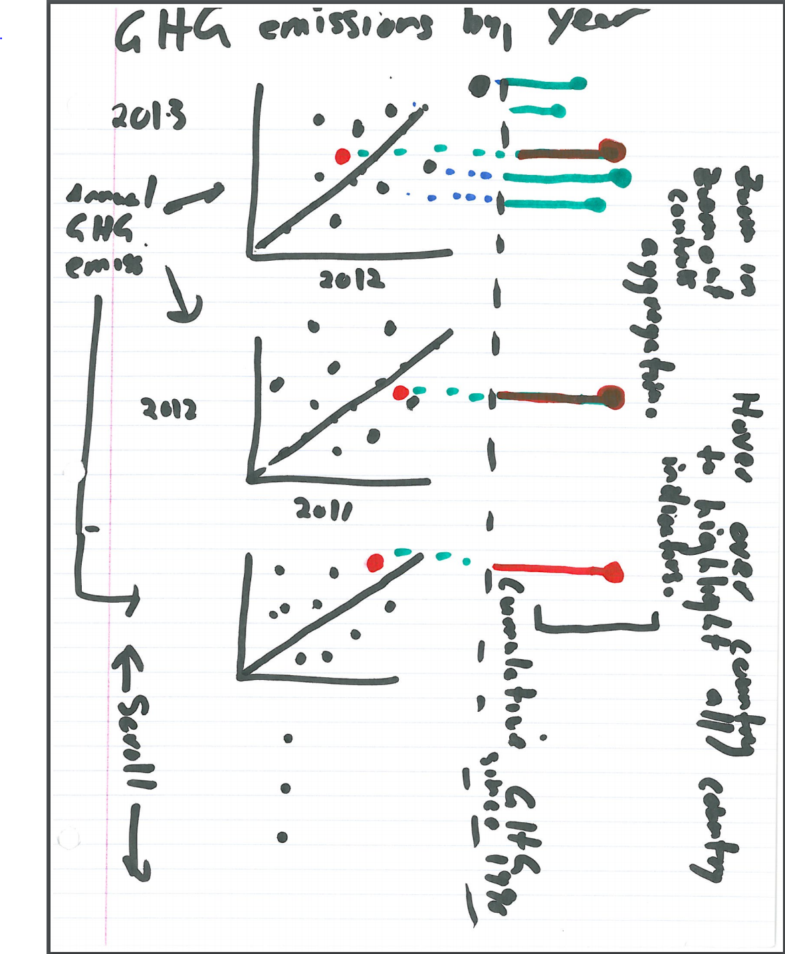

**Map here**

# Open Questions

I am a bit concerned about being able to make all of the hover overs, zoom in/out and scroll functionality work, (in particular aggregating when we zoom out and splitting when we zoom in).

Schedule:

I have decided to implement sketch 4 for this project. My tentative schedule is as follows:

October 18, 2017:

Firstly, I would like to fork the project template and find my bearings in its environment. I would then like to finish the core function that creates each scatter plot and (hopefully lollipop graph) and test it for one set of years.

October 26: Figure out how to mouse over and select/identify a country. I would also be happy to figure out how to zoom in and out, scroll across the viz and link elements of the graphs.

November 2: If I actually finish the above, figure out how to place a world map at the base of the screen and zoom in and out.

November 9: Clean up and deliver the final project.